**FRINDOC User Guide**

**Background**

The FRINDOC project is managed by a consortium of six partners, coordinated by EUA, and consisting of the University of Hong Kong, Stellenbosch University, Imperial College London, the University of Bergen and the University of Camerino. The project is supported by the Erasmus Mundus programme of the European Commission.

The Framework for the Internationalisation of Doctoral Education (FRINDOC) project aims at providing a comprehensive overview of good practices and valuable experiences for universities. The project is developing a framework containing a statement of good practice on internationalisation and this online tool for universities to aid the planning and implementation of internationalisation strategies for doctoral education.

Doctoral candidates are one of, if not the, most mobile group within universities. Therefore, the strategic importance of doctoral education in successfully implementing visions for internationalisation is very high. Successful internationalisation of doctoral education strengthens research, teaching and international outreach of universities. It is hence essential that universities have access to the information and resources necessary to implement their internationalisation strategies for doctoral education.

**The purpose and format of the FRINDOC self-evaluation tool**

The FRINDOC tool has been designed specifically for *self-evaluation purposes.* It should function as a strategic tool for planning, promoting and supporting mobility in doctoral programmes enabling universities to attain a united picture of strategic goals, capacity and possibilities to implement the right structures for their particular profile. The tool is not designed for benchmarking purposes and should be considered as a developmental aid for institutions as they seek to build, implement or revise strategies for the internationalisation of doctoral education. It can be used as a one off exercise or engaged with on repeated occasions. The project team are also in the process of developing a statement of good practice on internationalisation which will eventually be available for users as a resource to assist them in completing the tool.

The tool adopts the format of a questionnaire which asks users to consider their current status and corresponding goals in a range of areas by assigning ratings on a scale of 0-5 (0 meaning a poor rating and 5 meaning excellent). The questions are divided into four broad areas:

* Research Capacity
* International Profile
* Institutional Framework
* Mobility

The ratings the user chooses cannot be considered as right or wrong, but it is important that they are selected in a coherent manner. To assist in this, the tool requires that the user completes all of the information on the first page, ‘General Information’, including selecting and/or defining a context within which they are evaluating their own university. This should help the user to provide consistent responses and to better interpret the final report the tool will generate.

It is also strongly recommended to complete the ‘Comments’ box following each question as this will help to further contextualise the final report generated. In cases where a team cannot reach consensus in terms of the ratings to be assigned, it could then be commented on that an agreement could not be reached on that particular rating and why this is the case.

The final report generated by the tool takes the format of a spider diagram, which visually indicates the current status of the institution in the various areas asked about, as well as a full account of the ratings and comments provided by the user. The spider diagram will be based on the framework below:

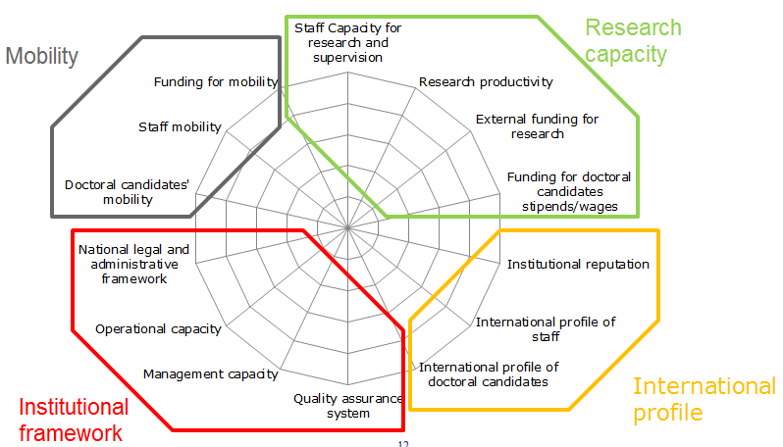

Note that the question responses are weighted and the responses for each heading are aggregated to give an overall score in the final spider diagram, as opposed to showing responses for each individual indicator. The final scale therefore goes up to 10 as opposed to 5.

**Tips on how to approach the self-evaluation exercise within your institution**

Having worked with a pilot group of institutions who shared their experiences of using a draft of the tool, the following tips were collated to assist universities in getting the most out of the FRINDOC tool:

* First and foremost, it is very important to understand the self-evaluation context of the tool. The exercise should be approached with the mindset of engaging in a quality enhancement project. The tool encourages a focus on processes and, therefore, it would not be particularly useful to place excessive emphasis on KPIs. If using the tool is considered as a developmental exercise that can be revisited in the future, the outputs are likely to be more beneficial
* It is highly recommended to adopt a collaborative approach to complete the tool within your institution and to consult with colleagues from various sections before assigning ratings. You can choose to either fill in the tool from the perspective of the entire institution or to set up ‘child accounts’ so that the tool can be completed from the perspective of multiple units. In either case, a coordinator should be designated to organise the process. An example of the approach the coordinator could take is as follows:
* Identify suitable people to participate in the process
* Possibly set up ‘child accounts’ for different departments
* Brief senior management and those directly involved in the process
* Analyse the questions asked in the tool with a view to deciding on definitions of terms and the data which will be required (suggestions are provided below)
* Organise an information session for all of those involved or selected representatives of various units/faculties
* Compile the information submitted and prepare a comprehensive report
* Organise a feedback session for all of those involved or selected representatives of various units/faculties to facilitate open discussion of the results
* On the General Information page you are asked to select a context within which you are choosing to rate your own university and its goals. While the tool has been explicitly designed for self-evaluation purposes, choosing a context within which to evaluate your own university is a way of encouraging consistency in your responses and keeping a broader context in mind when interpreting the final report the tool will generate. It is essential that the team completing the tool have a common understanding of the chosen context and try to agree on the interpretation of each question. Clarifications have been provided in the tool regarding the questions but you are encouraged to interpret the questions according to your institution’s particular needs. It is also strongly recommended to complete the ‘Comments’ box following each question as this will help to further contextualise the final report generated. In cases where a team cannot reach consensus in terms of the ratings to be assigned, it could then be commented on that an agreement could not be reached on that particular rating and why this is the case
* When assigning ratings for the goals you are also invited to elaborate on the instruments you could use in order to work towards these goals. The Statement on Internationalisation can be used to provide inspiration in this regard

**Technical considerations**

The tool is user friendly and should not pose difficulties to use.

The first step is to register and create your account, which you can do by entering your email address and selecting a password.

You must complete the General Information page in order to access the rest of the tool. On this page, you will also have the possibility of creating ‘child accounts’ so that multiple people from within the institution can access the tool and answer the questions from the perspective of their particular faculty/unit. Different email addresses and passwords are required for each ‘child account’.

You can now proceed to the ‘Current Status and Goals’ section where you can select ratings corresponding to the current situation and intentions of your institution. In order to select a rating in the tool, hover your mouse over the circles and click on the relevant one. Each question also allows for text entry. You can insert as much text as you like (even though the text box may be small).The scale ranges from 0 – 5 and we suggest you bear the following interpretation in mind when completing the tool:

**0 – 1** = We do worse than the universities within our chosen context

**2 – 3** = We do as well as the universities within the chosen context

**4 – 5** = We do better than the universities within the chosen context

To facilitate a collaborative approach to completing the tool within your institution, it is also possible to download all of the questions in Word or PDF format from the upper right-hand corner of any of the pages

You can move forwards and backwards through the questions as much as you like. Please always click the ‘next’ button at the bottom of each page to ensure that your answers are saved.

Please be aware that the FRINDOC tool requires reflection, communication with colleagues and knowledge of a certain amount of data about your institution, so you may not want to fill it out all at once. All of your work will be saved, and you are free to enter and exit at your own pace. You can return anytime by entering your Username and Password.

When you have completed the tool, you will have the option to print the resulting spider diagram and answers to the questions in PDF format.

Should you have any technical problems, please contact EUA at [joanne.byrne@eua.be](mailto:joanne.byrne@eua.be)

**Recommended data to have at hand when using the tool**

*In order to fully benefit from the tool, certain data should be fed into it. The list below is not categorical. Neither is it strictly necessary to have all of this information. The institutional coordinator is advised to check the list, make changes and add recommendations for colleagues where s/he thinks they are relevant. Anecdotal evidence can also be helpful. (Where possible, finding similar information for institutions within the chosen context would also be of use)*

*Section A – Research Capacity*

* The amount of national and international funding the institution has received in the previous 5 years
* Time records of academic staff
* Information regarding compulsory and optional training for PhD supervisors in the institution
* Supervisor/student ratio
* Number of annual doctoral graduations in the institution
* Research output, for example in bibliometric terms
* The amount of competitive external funding received in the previous 5(?) years
* The amount of internal funding provided by the institution for doctoral candidates
* Results of external research evaluations

*Section B – International Profile*

* The number of international research staff in the institution
* Number of international doctoral candidates
* Opportunities for doctoral candidates to learn the national language/foreign languages
* Number of strategic international partnerships, agreements, double degrees etc.
* Number of staff engaged in international networks

*Section C – Institutional Framework*

* Relevant internal quality assurance procedures
* Relevant external quality assurance procedures
* Management of travel, visa applications etc.
* Visa rules and restrictions

*Section D - Mobility*

* The frequency with which doctoral candidates engage in mobility (long-term, short-term, conference attendance)
* Funding available for mobility of doctoral candidates
* The frequency with which supervisors engage in mobility

**Proposed definitions of terms**

*The list below is not categorical. Users are free to change definitions to suit different contexts. The institutional coordinator is advised to check the list, make changes and add additional terms where s/he thinks they are relevant for colleagues.*

* **Doctoral candidate:** A person conducting research and / or aiming to submit a thesis with the goal of acquiring a doctoral degree
* **Staff:** Full-time equivalent research staff employed by the institution, not including doctoral candidates
* **Research capacity:** The capacity of the institution to carry out research according to internationally recognised standards in terms of trained research staff, equipment and funding
* **Institutional reputation:** Reputation of the institution in terms of research, teaching and overall quality
* **Internal QA:** Quality assurance processes and structures that are managed within an institution
* **External QA:** The form of this varies from system to system and can include institutional evaluations of different types; subject or programme evaluations; accreditation at subject, programme and institutional levels; and combinations of these
* **National legal and administrative framework:** National rules and regulations
* **Short-term mobility:** Mobility periods of three months or less, not including attendance at conferences
* **Long-term mobility:** Mobility periods of longer than three months